

**Software Requirements**

**Specification**

**for**

**Read O’write**

**Version 1.0 approved**

**Prepared by Noor-ul-Anam Ruqayya**

**UBIT, University of Karachi**

**9/6/2018**

**Table of Contents**

|  |  |  |  |
| --- | --- | --- | --- |
| **Table of Contents ..........................................................................................................................** | | | **ii** |
| **Revision History ............................................................................................................................** | | | **ii** |
| **1.** | **Introduction ..............................................................................................................................** | | **1** |
|  | 1.1 | Purpose ............................................................................................................................................ | 1 |
|  | 1.2 | Document Conventions .................................................................................................................... | 1 |
|  | 1.3 | Intended Audience and Reading Suggestions .................................................................................. | 1 |
|  | 1.4 | Product Scope .................................................................................................................................. | 1 |
|  | 1.5 | References ........................................................................................................................................ | 1 |
| **2.** | **Overall Description ..................................................................................................................** | | **2** |
|  | 2.1 | Product Perspective ......................................................................................................................... | 2 |
|  | 2.2 | Product Functions ............................................................................................................................ | 2 |
|  | 2.3 | User Classes and Characteristics ..................................................................................................... | 2 |
|  | 2.4 | Operating Environment .................................................................................................................... | 2 |
|  | 2.5 | Design and Implementation Constraints .......................................................................................... | 2 |
|  | 2.6 | User Documentation ........................................................................................................................ | 2 |
|  | 2.7 | Assumptions and Dependencies ...................................................................................................... | 3 |
| **3.** | **External Interface Requirements ...........................................................................................** | | **3** |
|  | 3.1 | User Interfaces ................................................................................................................................. | 3 |
|  | 3.2 | Hardware Interfaces ......................................................................................................................... | 3 |
|  | 3.3 | Software Interfaces .......................................................................................................................... | 3 |
|  | 3.4 | Communications Interfaces ............................................................................................................. | 3 |
| **4.** | **System Features ........................................................................................................................** | | **4** |
|  | 4.1 | System Feature 1 .............................................................................................................................. | 4 |
|  | 4.2 | System Feature 2 (and so on) ........................................................................................................... | 4 |
| **5.** | **Other Nonfunctional Requirements .......................................................................................** | | **4** |
|  | 5.1 | Performance Requirements .............................................................................................................. | 4 |
|  | 5.2 | Safety Requirements ........................................................................................................................ | 5 |
|  | 5.3 | Security Requirements ..................................................................................................................... | 5 |
|  | 5.4 | Software Quality Attributes ............................................................................................................. | 5 |
|  | 5.5 | Business Rules ................................................................................................................................. | 5 |
| **6.** | **Other Requirements ................................................................................................................** | | **5** |
| **Appendix A: Glossary....................................................................................................................** | | | **5** |
| **Appendix B: Analysis Models .......................................................................................................** | | | **5** |
| **Appendix C: To Be Determined List ............................................................................................** | | | **6** |

**Revision History**

|  |  |  |  |
| --- | --- | --- | --- |
| **Name** | **Date** | **Reason For Changes** | **Version** |
|  |  |  |  |
|  |  |  |  |
| - | - | - | - |
| - | - | - | - |

**1. Introduction**

**1.1 Purpose**

The purpose of this document is to present detailed information about Read O’write 1.0. It will describe the purpose, function and features of the system. It will also explain interfaces and the constraints of the system. This document is intended for developers and designer of the application.

**1.2 Document Conventions**

This document uses the following conventions DB(database).

**1.3 Intended Audience and Reading Suggestions**

This SRS is made specifically for the development and marketing team to help them in the development and marketing of Read O’write.

**1.4 Product Scope**

This product is designed to be used by people who are interested in reading or writing stories. It is an easy enough app to help people share their thoughts and talent.

**1.5 References**

No references are required.

**2. Overall Description**

**2.1 Product Perspective**

Read O’write is designed to be used by people who are interested in reading or writing a story. They do not have to wait for months to publish their story, all they need to do is sign up the app or connect through social networks and write, read or add a story to their collection. A web application will be launched soon afterwards which could be used by every registered user of Read O’write.

**2.2 Product Functions**

The major functions performed by Read O’write are,

* Read a story
* Continue reading
* Write a story
* Add a story to collection

**2.3 User Classes and Characteristics**

There are two types of users that interact with this system,

* **Reader:**

Reader could use this application to read a story without having to download it separately or save it to collection to read later.

* **Writer:**

Writer could use this application to write up a story and share it on the application without having to wait days to publish it. In that way people are able to use their share their talents with others.

**2.4 Operating Environment**

Read O’write is designed to be used on a simple android phone with internet connection once it has been installed from the Google play store No additional hardware or software component is required in order to use the Application. The Web Application will soon be available which could be used on any Personal Computer or Laptop with a browser and internet connection.

**2.5 Design and Implementation Constraints**

The Application can be installed from Google play store and you need to sign up before using it. You can also sign in through facebook or Google. After signing up, the user may write or read a story, continue reading or add a story to the collection to read later.

**2.6 User Documentation**

User will be provided with a help button on the home screen that will provide them with basic details about the application and its components.

**2.7 Assumptions and Dependencies**

If the user has allocated the resources to something in the first place then the application could malfunction or one or more than one features could be unavailable.

**3. External Interface Requirements**

**3.1. User Interfaces**

There are a total of five interfaces in the application.

1. **Start page:**

Start page is provided with four buttons and a help button on the bottom. Each of which will navigate to other pages of the application.

1. **Writing script page:**

A script page will be opened upon click which will enable user to write a story, save it, delete it, add new page, move between different pages and share the story online.

1. **Reading script page:**

This page will have a script of the story with two button to navigate between pages and a cross which will save the story and navigate back to the book collection.

1. **Search:**

Search page will provide the user with a search bar which will enable him to search for any story which he can add to collection or read it online.

1. **Book collection:**

This page will provide the user with an option to add stories into their private collection to read it later.

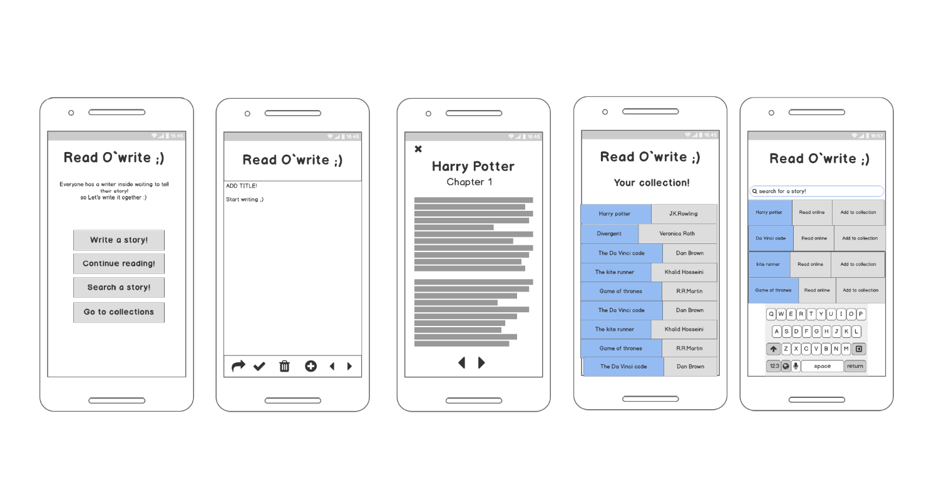

**3.2. Hardware Interfaces**

This app could be used on any android phone with version 4.0 or more. No additional hardware is required for this purpose.

**3.3 Software Interfaces**

This application will require android version 4.0(or more) or Windows 7(and more). No other software or extra storage will be required for the application.

**3.4 Communications Interfaces**

The communication between the different parts of the system is compulsory as they are related to each other. However, in what way the communication is achieved is not important for the system and is therefore handled by the underlying operating systems for both the mobile application and the web portal.

**4. System Features**

Read IO’write has the following features

**4.1 Search story**

4.1.1 Description and Priority

User will be able to search through the database for any story. It is a high priority feature.

4.1.2 Stimulus/Response Sequences

1) New window with a search bar will pop up.

2) Search for a story.

3) A grid of related stories is shown.

4) Selects a story to read online.

5) Add the story to collection.

4.1.3 Functional Requirements

A grid with related stories will be displayed.

**4.2 Read story**

4.1.1 Description and Priority

User will be able to search through the database for any story. It is a high priority feature.

4.1.2 Stimulus/Response Sequences

1) User will click on the read online button.

2) A page with the script of the story is opened.

3) Use arrows to navigate between pages.

4.1.3 Functional Requirements

Script of story will be displayed to be read.

**4.2 Write story**

4.1.1 Description and Priority

User will be able to write a story.

4.1.2 Stimulus/Response Sequences

1) User selects the ‘write a story’ option from the main menu.

2) User writes story into the script page.

3) User publishes the story.

4.1.3 Functional Requirements

Script of story will be uploaded.

**5. Other Nonfunctional Requirements**

**5.1 Performance Requirements**

* **Efficient search feature:**

Story will be efficiently and effectively searched through the database.

* **Upload stories frequently:**

User will not have to wait for days or weeks or put their stories online.

* **Independent of active connection:**

Internet connection is required for only search or upload story. Reading saved stories does not requires active connection.

**5.2 Safety Requirements**

User must not share their personal information such as passwords, credit card information or house number with any other user.

**5.3 Security Requirements**

User must be logged into the system and provide none other personal details to other users.

**5.4 Software Quality Attributes**

**Reliability:**

The probability that this system fulfills a function that is defined in the above functional requirements.

**5.5 Business Rules**

Every user is able to perform all of the general functions i.e read,search or write but one user cannot delete another user’s story.

**6. Other Requirements**

The story uploaded under the name of a user must be copied or the user will be banned permanently from the application.

**Appendix A: Glossary**

**Appendix B: Analysis Models**

**Appendix C: To Be Determined List**